CLINICAL STUDY PROTOCOL

〔PROTOCOL TITLE〕

VERSION NO.
DATES (YYYYMMDD)
填寫說明: 計劃書一定要註明版本、日期，若有修正變更，版本、日期務必同時更新

INVESTIGATORS
SITES

Table of Contents

Section Page
- Synopsis 1
- Introduction and Rationale
- Objectives and Endpoints
  - Study Objectives
  - Study endpoints
- Study Design
  - Overall Design (Flow Chart)
  - Number of Patients
  - Schedule of Activities (Time-Event scheme)
- Study Population
  - Inclusion Criteria
  - Exclusion Criteria
  - Withdrawal criteria
- Treatments
  - Treatments Administration
  - Concomitant Therapy
- Efficacy Assessments
- Safety Assessments
- Adverse Event reporting
  - Definition and reports of Adverse Events
  - Adverse event follow-up
- Criteria for the termination of the trials
- Statistical Considerations
  - Sample Size Determination
  - Planned Statistical methods of analysis
    - Efficacy analyses
    - Safety analyses
    - Additional analyses
    - The level of significance
    - Analysis Population
- Direct access to source data/documents
- Ethical considerations
- Data handling and keeping
- Financing and Insurance
- References

填寫說明: 計劃書用中文或英文撰寫均可，但建議盡量以英文撰寫，尤其是預計登錄臨床試驗公開網站(clinicaltrials.gov)之臨床試驗計畫。
(註: 依據國際醫學雜誌編輯委員會（The International Committee of Medical Journal Editors,ICMJE）之投稿規定(2005年起)，經IRB通過之臨床試驗計畫投稿者須於招募第一位受試者參與試驗前，將通過IRB審核之臨床試驗計畫資料登錄於臨床試驗公開網站。完成登錄作業後，國際醫學雜誌編輯委員會（ICMJE, International Committee of Medical Journal Editors (ICMJE)，始可同意接受研究結果之發表。
※未完成臨床試驗登錄之計畫案，ICMJE有權不接受其文章發表。）

Synopsis

Protocol Title：

Study Objectives：

Investigational product(s)：
填寫說明: product(s)包含: 藥品、醫療器材、中醫藥、處置方式…等。
Development Phase：⃞ I ⃞II ⃞III ⃞IV ⃞其它______ ⃞不適用
填寫說明: 如屬跨期別試驗 (I/II、 II/III…等)，請填寫於”其它”欄位。
Study Design：
- □ Experimental Group
□ Control Group ： □ Placebo
- Study Drug (Name、Dose、Usage) __________________
□ Other _____________
- Blinding：□ Open □ Evaluator-blind □ Single-blind(patient) □ Double-blind(patient+PI)
□ Double Dummy □ Other ______________
- Randomization: □ Yes □ No
- □ Parallel design □ Crossover design □ Other ____________ □ Not applicable
- Treatment Period：____________(days/weeks/months/years) □ Not applicable
6. Study Period: ___________years (or From DD/MM/YYYY to DD/MM/YYYY)
- Dose adjustment：□ Mandatory □ Selectively □ No □ Not applicable
- Study location：□ Single □ Multi-center □ Global
Endpoints (Outcome measure)：
填寫說明:1. 如果有多項評估指標，請分項條列敘述。2. 如屬跨期別試驗，應按期別各別描述。

- Primary endpoint:

- Secondary endpoints:

- Exploratory endpoints (if any):

Inclusion/Exclusion Criteria：
填寫說明:
1.納入及排除條件應分項條列敘述，並加上編號。
2.排除條件是指已經符合納入條件的前提下，但需要排除受試者的狀況(例如:治療類風溼性關節炎的免疫抑制劑，納入條件是”類風溼性關節炎”， 不要將”非類風溼性關節炎”列為排除條件。而是例如為了避免”肺結核復發”，所以將”曾經感染過肺結核”列為排除條件。)
3.納入及排除條件的內容宜採用操作型定義(例如:腎功能以Creatinine數值表示)。
4.如果有多組受試者，納入及排除條件應分組撰寫。

Study Procedures：
填寫說明:
1.請填寫受試者總人數(預計納入人數及可評估人數)，若有分組需列出各組人數(建議先依統計方法估算達到統計意義所需人數〔可評估人數evaluable number〕，加上預估可能提前退出人數，得出預計納入人數〔預計納入人數enrolled number〕)。
2.請說明各分組受試者要接受哪些治療、處置、檢查或檢驗，請依照各個訪視時間點列出。
3.上述試驗程序請參考”試驗流程圖及/或評估時程表”撰寫。
4.若有檢體採集，請說明各種檢體要運送至哪裡(儲存)?由誰?進行那些處理(例如:離心…)?那些檢驗分析項目?(需條列並詳述各種檢驗分析項目)。
5.若要收集臨床資料或進行問卷，應詳述臨床資料項目與問卷種類(問卷應列為附件)。
6.請說明研究後剩餘檢體之處理方式(例如:銷毀、儲存至組織銀行或人體生物資料庫)。

Concomitant Treatments： □不適用
1. Concomitant Therapy：
2. Prohibited Therapy：
Statistical Methods：
- Main study Hypothesis： □ Equality □ Superiority □ Non-inferiority
⃞ Equivalence □ Other ________
- Estimated Sample Size：整個試驗預計納入人數_______，整個試驗可評估人數______
本中心預計納入人數_______，本中心可評估人數_______
- Efficacy assessment group： □ Intent-to-treat (ITT) □ Per-Protocol (PP)
□ Other ________
附註：意圖治療：Intent-to-treat (ITT)；依計畫書：Per-Protocol (PP)
- Interim analysis： □ Yes □ No
- Statistical methods：
- Handling of Missing Data：

- Introduction and Rationale

2.1 Investigational product(s)
填寫說明:請加入有關試驗藥品、醫療器材、中醫藥、處置方式之名稱及介紹。若無，請填寫不適用Not Applicable.

2.2 Animal and preclinical study data
填寫說明:請加入相關具有潛在性臨床意義之非臨床研究，和相關試驗之結果摘要。若無，請填寫不適用Not Applicable

2.3 Clinical data
填寫說明:請加入相關之臨床研究相關試驗之結果摘要。若無，請填寫不適用Not Applicable

2.4 Risks / benefits Assessment
填寫說明:請加入對於本研究對人體已知及未知之危險與利益。

2.5 Regulatory
填寫說明:請加入本研究將遵守藥品優良臨床試驗規範及相關法規。 (建議可參照下列範例撰寫)

For example:
This study will be conducted in compliance with the protocol approved by the Institutional Review Board, and according to Good Clinical Practice standards. No deviation from the protocol will be implemented without the prior review and approval of the IRB except where it may be necessary to eliminate an immediate hazard to a research subject. In such case, the deviation will be reported to the IRB as soon as possible.

Objectives and Endpoints
填寫說明:
1.請加入對試驗目的的描述，並針對試驗目的定義相對應的評估指標。
2.評估指標請區分成主要、次要及探索性評估指標分別敘述。
3.可採條列式或表格式(擇一)撰寫。

建議書寫方式一(條列式)
3.1 Study Objectives:
3.1.1 Primary objective:
3.1.2 Secondary objectives:
3.1.3 Other exploratory objectives (if any):

3.2 Study endpoints:
3.2.1 Primary endpoint:
3.2.2 Secondary endpoints:
3.2.3 Other exploratory endpoints (if any):

建議書寫方式二(表格式)
Objectives | Endpoints
Primary
1.  2.  … | 1.  2.  …
Secondary
1.  2.  … | 1.  2.  …
Exploratory
1.  2.  … | 1.  2.  …

Study Design

Overall Design
填寫說明:
1.請簡述試驗的期別、是否有分組(分成幾組)、若有分組是否為隨機分配、是否為安慰劑對照或活性對照、治療期間多久、治療後追蹤觀察多久、試驗執行地點、是否為多中心試驗…。
2.建議繪製試驗流程圖(Flow Chart)，請參考下圖範例。
註: 試驗流程圖是指整個試驗之執行流程。評估時程表是指個別受試者之試驗過程。

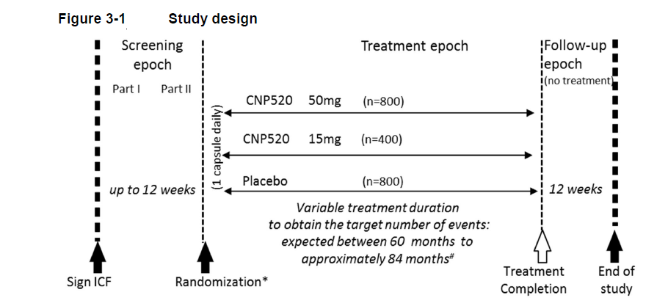
Flow Chart (試驗流程圖)：
example:

Number of Patients
填寫說明:
請填寫受試者總人數(預計納入人數及可評估人數)，若有分組需列出各組人數(建議先依統計方法估算達到統計意義所需人數〔可評估人數evaluable number〕，加上預估可能提前退出人數(未完成全部試驗程序之受試者)及篩選失敗人數(不符合納入排除條件者)，得出預計納入人數〔預計納入人數enrolled number〕)。
註: 納入人數指所有簽署同意書之受試者人數，受試者須先簽署同意書後才能進入篩選程序。
納入人數-篩選失敗人數-提前退出人數=完成試驗人數(可評估人數)

Schedule of Activities

填寫說明:
1.首先須先決定每位受試者從篩選至完成追蹤將接受多少次訪視、每次訪視將進行哪些程序，然後製作評估時程表(Time-Event scheme，請參見範例)。
2.一般會包括:篩選階段、治療階段、追蹤階段。
3.表格最左邊欄位填寫試驗預計執行的程序，其他欄位則說明何時會進行該項程序。
註: 試驗流程圖是指整個試驗之執行流程。評估時程表是指個別受試者之試驗過程。

Example:
Time-Event scheme(評估時程表):

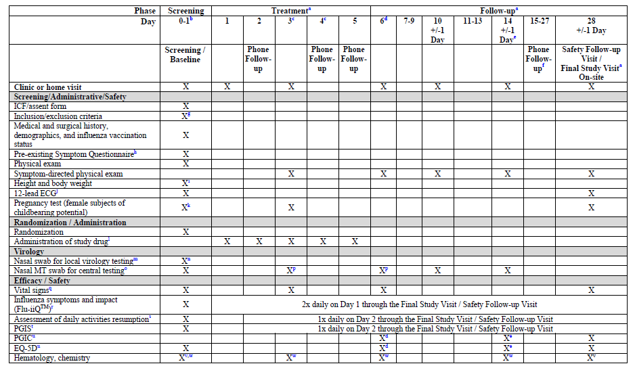

Study Population
填寫說明:
1.納入及排除條件應分項條列敘述，並加上編號。
2.排除條件是指已經符合納入條件的前提下，但需要排除受試者的狀況(例如:治療類風溼性關節炎的免疫抑制劑，納入條件是”類風溼性關節炎”，不要將”非類風溼性關節炎”列為排除條件。為了要避免”肺結核復發”，所以將”曾經感染過肺結核”列為排除條件。)
3. 納入及排除條件的內容宜採用操作型定義(例如:腎功能以Creatinine數值表示)。
4. 如果有多組受試者，納入及排除條件應分組撰寫。.

5.1 Inclusion Criteria

Example:

Disease group
Inclusion criteria:

(2)
(3)
...
Health group
Inclusion criteria：
(1)
(2)
(3)
…

5.2 Exclusion Criteria

Example:

Disease group
Exclusion criteria:
(1)
(2)
(3)
...
Health group
Exclusion criteria：
(1)
(2)
(3)
…

5.3 Withdrawal criteria
填寫說明:
1.請條列出受試者退出試驗條件、何時及如何退出試驗、退出之受試者之數據之種類及時間點、是否和如何填補退出之受試者、退出之受試者之追蹤。
2.常見之退出試驗條件包括: 因為發生不良反應、不遵從試驗程序、嚴重違反試驗程序、受試者撤回同意…。

Treatments

6.1.Treatment Administration
填寫說明: 請詳細說明受試者在試驗過程將接受之試驗藥品(包括對照藥品、背景治療)、醫療器材、中醫藥、處置方式之使用方式。以試驗藥品為例，請敘述使用劑量、投與方式、投與頻率、投與期間多久…。

Concomitant Therapy
填寫說明:請加入試驗前及試驗期間准許及禁止使用的藥品或治療。若無，請填寫不適用Not Applicable

Efficacy Assessments
填寫說明:
1.請明列本研究中用以評估療效的參數。例如降血糖藥物常用Hb1Ac、癌症用藥常用overall survival (OS)或progression free survival (PFS)…。.
2. 請明列評估、記錄、和分析上述療效參數之方法及時間點(參考評估時程表)。

- Safety Assessments

填寫說明:
1. 請明列本研究中用以評估安全性的參數。例如: ALT，AST，CCr…。
2. 請明列評估、記錄、和分析安全性參數之方法及時間。

- Adverse event reporting
填寫說明:請說明試驗期間發生的不良事件及其它疾病的通報流程與方式，請注意不良事件的通報須符合IRB的規定及國內法規。(建議可參照下列範例撰寫)

Example:
[請填寫通報者名稱] will report SAEs to the IRB of Chang Gung Medical Foundation according to the Serious Adverse Event Reporting Procedures and Guidelines as posted in the Clinical Trials Resource on the website of Chang Gung Medical Foundation IRB. SAE reports to the IRB should include the following information when calling the Medical Monitor:
- Date and time of the SAE
- Date and time of the SAE report
- Name of reporter
- Call back phone number
- Affiliation/Institution conducting the study
- Protocol number
- Title of protocol
- Description of the SAE, including attribution to drug and expectedness

9.1 Definitions and reports of Adverse Events
填寫說明:請對可能於本研究進行時所發生的不良事件提出定義(建議參考下列範例撰寫)。

Example:
All adverse events that occur after the informed consent is signed (including run-in) must be recorded on the adverse event CRF (paper and/or electronic) whether or not related to study agent. AE Data Elements including:
- AE reported date
- AE Verbatim Term
- CTCAE Term (v 5.0)
- Event onset date and event ended date
- Severity grade
- Attribution to study agent (relatedness)
- Whether or not the event was reported as a Serious Adverse Event (SAE)
- Action taken with the study agent
- Outcome of the event
- Comments

Identify the adverse event using the NCI Common Terminology Criteria for Adverse Events (CTCAE) version 5.0. The CTCAE provides descriptive terminology and a grading scale for each adverse event listed.

AEs will be assessed according to the CTCAE grade associated with the AE term. AEs that do not have a corresponding CTCAE term will be assessed according to their impact on the participant’s ability to perform daily activities as follows:

Grade | Severity | Description
1 | Mild | - Barely noticeable, does not influence functioning  - Causing no limitations of usual activities
2 | Moderate | - Makes participant uncomfortable, influences functioning  - Causing some limitations of usual activities
3 | Severe | - Severe discomfort, treatment needed  - Severe and undesirable, causing inability to carry out usual activities
4 | Life threatening | - Immediate risk of death  - Life threatening or disabling
5 | Fatal | - Causes death of the participant

The possibility that the adverse event is related to study drug will be classified as one of the following: not related, unlikely, possible, probable, definite.

DEFINITION of Serious Adverse Events: ICH Guideline E2A and GCP of Taiwan define serious adverse events as those events, occurring at any dose, which meet any of the following criteria:
- Results in death
- Is life threatening (Note: the term life-threatening refers to an event in which the patient was at risk of death at the time of the event; it does not refer to an event which hypothetically might have caused death if it were more severe).
- Requires inpatient hospitalization or prolongation of existing hospitalization
- Results in persistent or significant disability/incapacity
- Is a congenital abnormality/birth defect
- Events that may not meet these criteria, but which the investigator finds very unusual and/or potentially serious, will also be reported in the same manner.

9.2 Adverse event follow-up
填寫說明:請說明受試者於不良事件發生後之追蹤時間並將會以書面記錄之。(建議可參照下列範例撰寫)

Example:
All AEs, including lab abnormalities that in the opinion of the investigator are clinically significant, will be followed according to good medical practices and documented as such. Site staff should send follow-up reports as requested when additional information is available. Additional information should be entered on the IRB of Chang Gung Medical Foundation of SAE form in the appropriate format. Follow-up information should be sent to Chang Gung Medical Foundation IRB as soon as possible according to IRB’s Serious Adverse Event Reporting Procedures and Guidelines.

Criteria for the termination of the trial
填寫說明:請列舉說明何種情況下終止試驗。

Statistical Considerations
填寫說明:建議諮詢生物統計學專家

11.1 Sample size Determination

Example:
The study will be powered to approximately 80% assuming a hazard ratio of xx at a cumulative 1-sided alpha of .025. The number of patients required to observe approximately xxx events was calculated about xxx….

11.2 Planned Statistical methods of analysis
填寫說明:請說明本試驗採用的統計分析方法，包括分析的時間點及是否執行期中分析等。

Example:
Statistical analysis
Quantitative variables will be presented as mean±standard deviation (SD) and categorical variables will be presented as proportions. The Student t-test, Mann-Whitney U-test and Spearman rank correlation test will be used to analyze differences between groups of variables. Receiver operating characteristics (ROC) cures will be used to assess the discriminative power of mutations and methylation levels in ctDNA, serological markers and the 【】 index. The predictive performance of variables will be expressed as the area under the ROC curve (AUROC), sensitivity, specificity, positive predictive value (PPV) and negative predictive value (NPV).

11.2.1 Efficacy analysis

11.2.2 Safety analysis

11.2.3 Additional analysis

11.2.4 The level of significance
填寫說明:請說明本試驗決定統計檢定的顯著水準。

Example:
A p-value less than 【 】 was considered significant and was denoted by * and p-value less than【 】 was denoted by **.

11.3 Analysis Population

11.4 Procedure for accounting for missing, unused and spurious data
填寫說明:請說明對於缺失、未採用、及偽造資料的處理程序。

Example:
The incomplete clinical data and sequencing data with poor quality will be excluded in the study.

11.5 Procedures for reporting any deviation(s) from the original statistical plan
填寫說明:請說明違反計畫書所載之統計方法的報告程序。

Direct access to source data/documents
填寫說明:請確保在試驗計畫書或其他書面協議內，有列舉試驗主持人\機構對於試驗相關之監測、稽核，人體試驗委員會\獨立倫理委員會檢閱，及主管機關的查核時仍應給予其直接視察原始數據\文件之權利。.

Example:
Investigators permit IRB to access to the source data of experiment for trial-related monitoring, audits and regulatory inspection.

Ethical considerations
填寫說明:請加入倫理考量之敘述。(建議可參照下列範例撰寫)

Example:
This study will be conducted according to Taiwan and international standards of Good Clinical Practice for all studies. Applicable government regulations and Chang Gung Medical Foundation research policies and procedures will also be followed.

This protocol and any amendments will be submitted to the Chang Gung Medical Foundation Institutional Review Board (IRB) for formal approval to conduct the study. The decision of the IRB concerning the conduct of the study will be made in writing to the investigator.

All subjects for this study will be provided a consent form describing this study and providing sufficient information for subjects to make an informed decision about their participation in this study. This consent form will be submitted with the protocol for review and approval by the IRB. The formal consent of a subject, using the IRB-approved consent form, will be obtained before that subject is submitted to any study procedure. This consent form must be signed by the subject or legally acceptable surrogate, and the investigator-designated research professional obtaining the consent.

Data handling and keeping
填寫說明:請說明本研究中由誰來做資料的處理及分析，並請說明地點及時間等。另請完整補充說明研究所取得之資料/檢體於研究結束後之處理及保存方式，包括保存人、地點、年限及銷毀方式。(建議可參照下列範例撰寫)

Example:
Clinical samples will be collected in Chang Gung Medical Foundation. The sequencing data will be stored in computers of laboratory with an electronic encryption. The clinical and source data can only be assessed by clinical doctors and investigators of the study.

Financing and Insurance
填寫說明:請說明本研究中的利益迴避書面聲明、研究經費來源及是否有對本研究之受試者提供保險等訊息。若有保險請提供相關資訊。

- References
填寫說明:請整理與本研究相關之參考文獻與資料，若以短文摘要方式呈現尤佳。

